# View and Edit the Transformation Rules

* Our Eclipse solution bundle comes with a preinstalled version of the Henshin model transformation language. The contained editors allow you to view and edit our provided model transformation specifications:
  + **initialTransformations.henshin**
  + **mutations.henshin**
  + **utility.henshin**

Double-click on the .henshin_diagram file to open a rule set in the visual editor. Double-clicking the .henshin file instead will open the same rule set in a tree-based editor.

* In case you cannot find the “Properties” view that gives detailed information for the currently selected rule element, you can right-click anywhere on the editor canvas and choose “Open properties view”. Then the properties view will open. 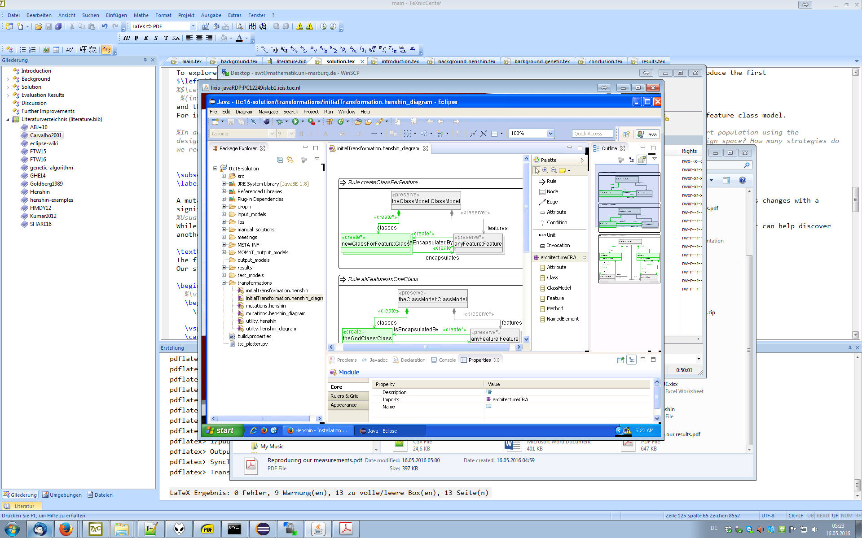
* More information on Henshin and its usage is found at <https://www.eclipse.org/henshin/examples.php?example=bank>